|  |  |
| --- | --- |
|  | |
| INSY6112A1 | |
| Student Number: | ST10439231 |
| Programme Code: | BCAD |
| Module Lecturer: | Mick |
| Module Code: | INSY6112 |
| Date of Submission: | 28-03-2025 |

|  |
| --- |
| I hereby declare that I did not plagiarise the content of this assignment and that this is my own work.  Assignment submitted via SafeAssign: (Tick the Box) |

Table of Contents

1 Question 1 1

2 Question 2 3

3 Reference List 4

# Question 1

The Database type that is best suited for this scenario is the NOSQL Database.

A NOSQL database is a non-relational, is easily scalable and flexible database. NoSQL databases are generally designed for large amounts of data and data that is not always fully structured. NoSQL is designed for distributed environments making them suitable for large amounts of data. (Mullins, Vaughan and Beal, 2021)

Having flexibility in the database is another reason why NOSQL is recommended. NoSQL allow for more flexibility with there data, social media platforms allow for all types of like images and comments, this is why having flexibility is important. NoSQL allow semi-structured or structureless databases. (Smallcombe, 2024)

Scaling is one of the points why NoSQL is being recommended. NoSQL servers are designed and created for horizontal scaling, this allows for it to handle more servers and handle large amounts of data, this is the ideal for large applications. As said in the scenario a key challenge is the high-volume data, this is why scalability is key as the database will always be expanding and adding new data. Unlike relational database NoSQL Spreads the data effectively. (Atlan, 2023)

The architecture for NoSQL is well suited for Realtime data processing. Features like caching, partitioning and data replication are often natively supported and allows for quick read and write operations. This allows instant updates on things like user’s feeds, trending topics and stuff like that and enhancing the overall user experience. (Thomas, 2023).

Types of data that would be stored would be:

* Media posts that would include images, videos and live streaming data.
* User profiles that would include all the information about the users like bio and name.
* User responses like comments, shares and likes.
* User engagement patterns that will be stored for trending stories.

Key value data stores in key value pairs this helps ensure that high speed look up and scalability can be done in the database. Key value data stores have fast query performance and best suited for applications that require content caching. Some pros are that it is a simple data model and scalable. (Blazeclan, 2022)

Column orientated is that the data is organized in columns rather than rows. These column sets are also known as column families. Users can directly query the column families without having to go through the all the data records. This type is well suited for storing engagement metrics and popular topics. (Katz, 2022)

Document based databases helps store data in a document format like JSON, XML or BSON. Each document could represent a post or a profile or comment. Some features of this database type are that they have schema flexibility which allows for storages in various structures, Complex Data structures is the storage of nested documents. (Verpex, 2024)

Graph-orientated databases focus on the relationship between data elements. This makes it useful for things like social networks and recommendation engines. A graph-oriented database is optimised to capture and find the connection between elements. This type of database generally runs along side another database as it is hard to only use a graph-oriented database for a business. (MongoDB, 2022)

Volume, the platform generates large amounts of data. This data would include comments, likes, photos and other media content. A NoSQL database is key for handling the high volume of data that is always growing and expanding. (Gewirtz, 2018)

Velocity, this would mostly include the fast response time and real time updating and adding to the database. NoSQL databases provide low latency reads and writes and ensure that the user has a goof experience and has no performance issues. (Duckworth, 2023)

Variety, this would refer to how the data comes in many formats such as text, images or videos. NoSQL databases support unstructured, and semi structed data, this allows for the many different types of data to be entered into the system. (BU, 2017)

# Question 2

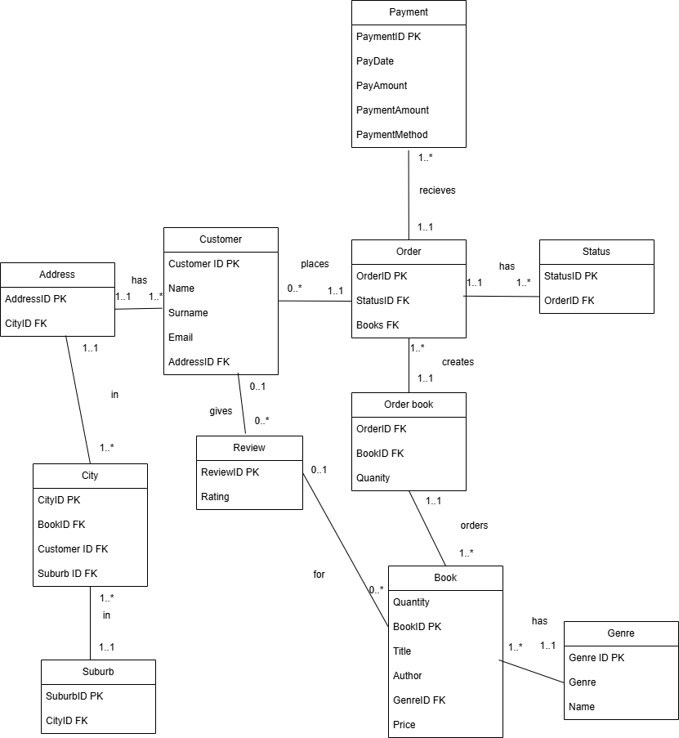

# Reference List

Atlan (2023). *Relational Database vs NoSQL: 15 Key Differences to Know!* [online] atlan.com. Available at: https://atlan.com/relational-database-vs-nosql/ [Accessed 27 Mar. 2025].

Blazeclan, T. (2022). *4 Types of NoSQL Databases & When to use them?* [online] Blazeclan. Available at: https://blazeclan.com/asean/blog/dive-deep-types-nosql-databases/ [Accessed 28 Mar. 2025].

BU, C.-S. (2017). *Understanding the 3 Vs of Big Data - Volume, Velocity and Variety*. [online] Coforge.com. Available at: https://www.coforge.com/what-we-know/blog/understanding-the-3-vs-of-big-data-volume-velocity-and-variety [Accessed 28 Mar. 2025].

Duckworth, D. (2023). *The 3 V’s of Big Data: Velocity Remains A Challenge for Many*. [online] Hazelcast. Available at: https://hazelcast.com/blog/velocity-remains-a-challenge/ [Accessed 28 Mar. 2025].

Gewirtz, D. (2018). *Volume, velocity, and variety: Understanding the three V’s of big data*. [online] ZDNet. Available at: https://www.zdnet.com/article/volume-velocity-and-variety-understanding-the-three-vs-of-big-data/ [Accessed 28 Mar. 2025].

Katz, E. (2022). *The 4 Types of NoSQL Databases You Need to Know*. [online] Spectral. Available at: https://spectralops.io/blog/nosql-databases/ [Accessed 28 Mar. 2025].

MongoDB (2022). *Types Of Databases*. [online] MongoDB. Available at: https://www.mongodb.com/resources/basics/databases/types [Accessed 28 Mar. 2025].

Mullins, C.S., Vaughan, J. and Beal, B. (2021). *What is NoSQL and How do NoSQL Databases Work?* [online] SearchDataManagement. Available at: https://www.techtarget.com/searchdatamanagement/definition/NoSQL-Not-Only-SQL [Accessed 27 Mar. 2025].

Smallcombe, M. (2024). *SQL vs NoSQL: 5 Critical Differences*. [online] Integrate.io. Available at: https://www.integrate.io/blog/the-sql-vs-nosql-difference/ [Accessed 27 Mar. 2025].

Thomas, D. (2023). *NoSQL for Real-time Analytics*. [online] www.lonti.com. Available at: https://www.lonti.com/blog/nosql-for-real-time-analytics [Accessed 27 Mar. 2025].

Verpex (2024). *What are the Four Types of NoSQL Databases*. [online] Verpex. Available at: https://verpex.com/blog/website-tips/what-are-the-four-types-of-nosql-databases [Accessed 28 Mar. 2025].